TROOP LOG

SUMMER CAMP
PITLOCHRY
Dunfallandy Estate¹

2nd-10th August
1977

Patrols

Whotly² Squad Rivets

P.L. Stuart Patrick P.L. Harry Lochhead
APL Murray Brabender A.PL. Guy Grant
Peter McLean Douglas Haldane
John Chalmers Robert Lawrie
Sandy Thomson Andrew Wilson
Donald Ross John Kerr^{2b}

Denims

P.L Paul Edgar
A.P.L. Bruce Black
Tommy Boag
Kenneth Kerr
Colin Roach

Bull Patrol

ASL Kenny Paton
ASL Graham Patrick
GSL Ian Black (not forgetting Rona)
ASL Alistair Cowe
V.S. Alastair Bennett
V.S. David McCreadie
V.S. Sandy Eadie (from 5th onwards)

Editorial comments
1. The troop was camping at the same campsite as used by the 70th during the 1950s. This was the location for Alistair Cram’s first summer camp as a Scout in 1957. Dunfallandy is on the minor road running south from Pitlochry on the est side of the River Tummell. The campsite was a flat piece of ground alongside the minor road (on the east side) and there were deciduous trees and a steep slope between the campsite and the river. The exact location is yet to be determined but is in the region of grid ref. 951561.
2. Spelling uncertain
2b Returned home early

Tuesday 2nd August

We assembled at 70th HQ at 9 AM – the rain was pouring from the heavens as we loaded the gear onto the Clyde Coast bus. The driver was the same one who in the previous year had run the troop to Wray Castle. I don’t think he was particularly pleased to see us.
The journey to Pitlochry seems to have been uneventful. Alastair Cowe and I travelled in the Paton mobile with most of the camp shop.

Just as the troop arrived in Pitlochry, there was a cloud burst and camp was pitched amongst heavy rain and periodic attacks by wasps which obviously didn’t like having their territory invaded by a horde of lively Scouts and were subsequently determined to get their own back.

We³ arrived at 4 o’clock and joined in the general melee of getting the camp up to shape.

Tea was communal and most of the evening was spent working on the campsite and getting acquainted with the surrounding area. Some Scouts went for a walk along the road adjoining the campsite.

After supper, everyone rather thankfully headed for pit. The Scouters, surprisingly, feeling as tired as the Scouts, headed into a somewhat quieter ‘Bell’⁴ than usual.

Scribe: Kenneth W. Paton ASL 70th

Editorial comments
3. Alastair Cowe and Kenny Paton in Kenny’s car
4. By tradition, Scouters slept in the only Bell tent owned by the troop

Wednesday 3rd August

The sun was a shining to welcome the day when the still tired looking Scouters were awakened by the inevitable screams of happy Scouts running around the campsite.
Breakfast was cooked by the patrols (the first patrol meal) and the rest of the morning was spent on site development and gadget making – the outstanding gadget being the drainage system leading to the wet pit by Bruce Black⁵. This continued to work efficiently throughout the entire camp.
After lunch of spaghetti hoops, the afternoon was free to explore Pitlochry and surrounding district. For the Scouts, this meant making the acquaintance of a very excellent milk bar⁶ in the town and various other ice cream booths. Visits to certain places of interest (e.g. the hydroelectric station) took place with varying degrees of interest.

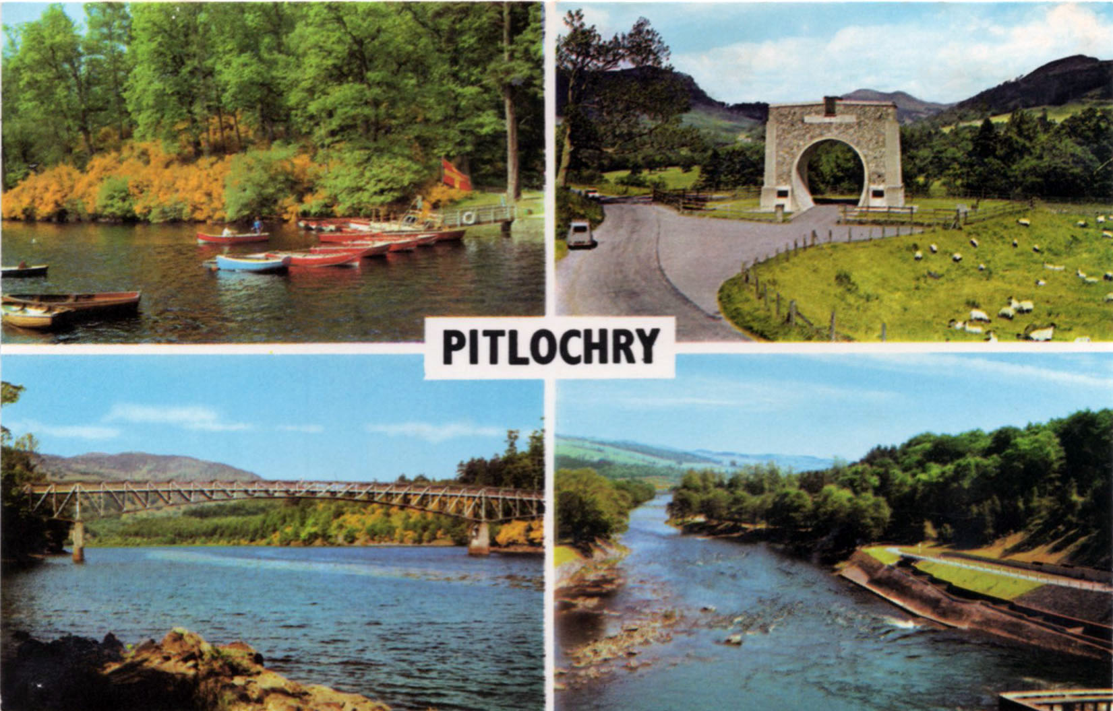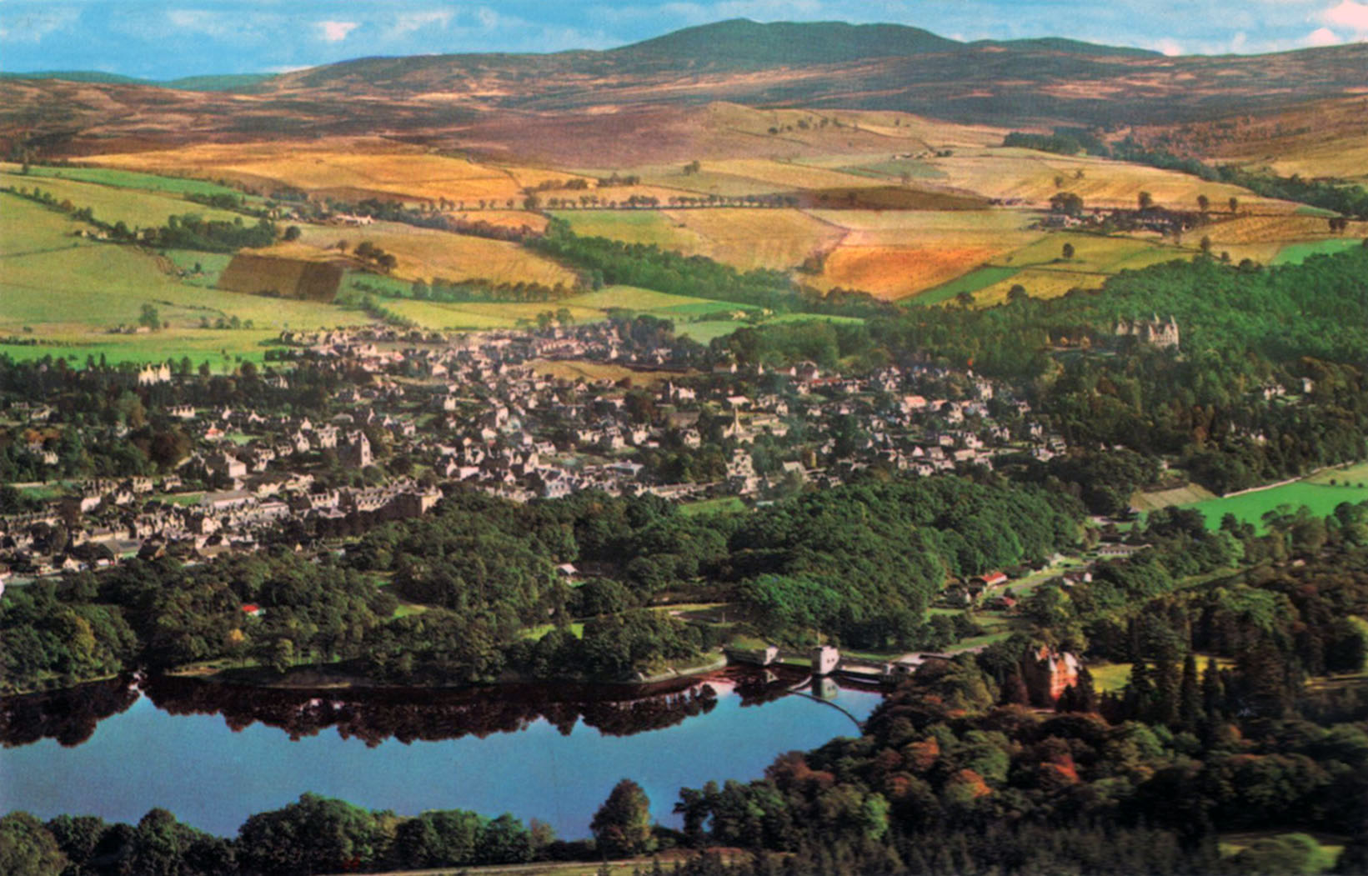
Pitlochry and Loch Faskally

When we returned to camp, the patrols began to prepare dinner with the privilege of having Scouters to eat with them for the first time.⁷ Let it be recorded that cooking was of a purely high standard – mince and tatties being well presented.
In the evening, hike planning for the ASS⁸ hikers, being Tommy Boag, Douglas Haldane, and Peter McClean, started, while training in various Scout Standard⁹ tests took place for the rest of the Scouts.
And so to pit.

Scribe: Kenneth W. Paton ASL 70th

Editorial comments
5. This consisted of a long roll of polythene which was designed to act as a chute. It may not have looked altogether pretty, but it was very effective.
6. Location to be identified
7. Scouters ate at different patrols for the evening meal to ensure that cooking was up to standard. Point were awarded towards the overall patrol championship held throughout camp
8. Advanced Scout Standard (ASS). This replaced the First Class badge in 1966, and was later replaced by the Explorer Badge. All these badges were part of a progressive Scout Training Scheme that no longer exists.
9. Scout Standard (SS). This badge replaced the Second Class badge in 1966 and was later replaced by the Pathfinder Badge. All these badges were part of a progressive Scout Training Scheme that no longer exists.

Thursday 4th August

Some time round about 3 o’clock, it started to rain ever so slightly heavier than usual. When we all eventually surfaced from pit, it was bucketing (which is putting it mildly). This it continued to do for the rest of the day, getting progressively heavier as time went on. Because the weather was so bad, the ASS⁷ hike had to be cancelled.¹⁰

After breakfast, the morning was spent mainly in keeping out of the rain in the patrol kitchen shelters and trying to do some basic training and testing. The rain refused to abate and it was still pouring at lunchtime.

After lunch, it became a question of survival as the campsite was gradually transformed into a paddling pool and the water level round about the tents began to rise to an alarming rate, thus demanding the building of trenches round about them to try and drain the water away.¹¹

Ian¹² and Kenny¹³ took the younger Scouts up to be to Blair Atholl and went on a tour round Blair Castle which was fascinating including Viscount Dundee’s breastplate with bullet hole.

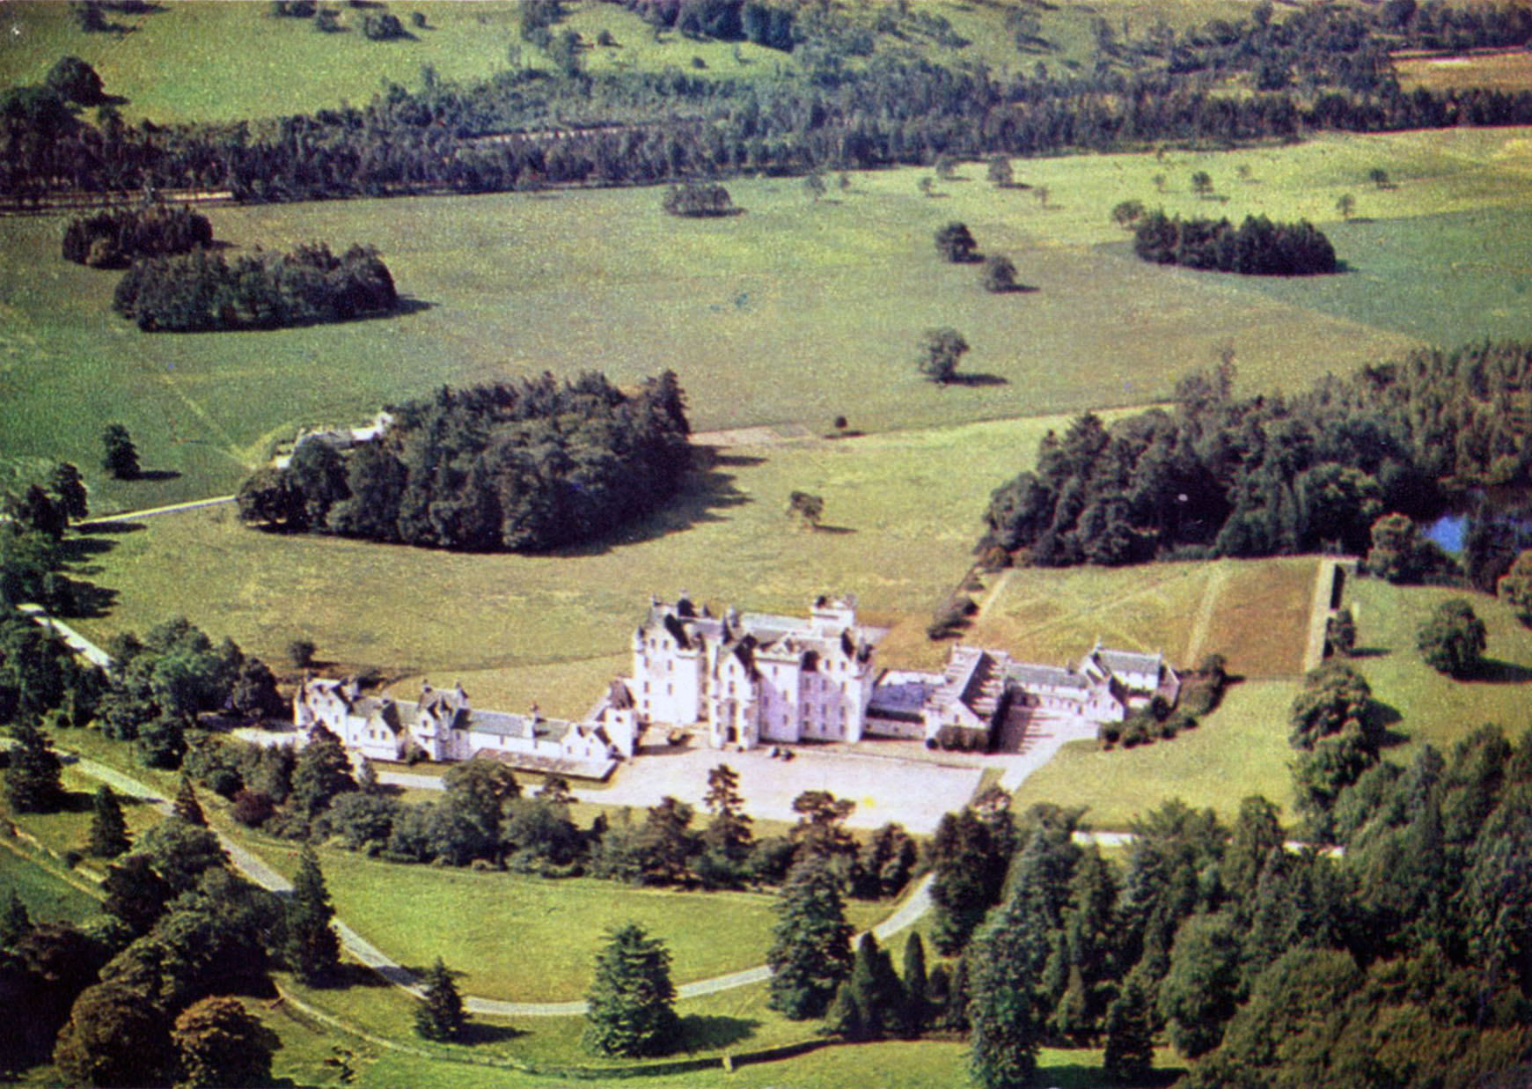
Blair Atholl Castle

The rain continued right into the evening and most of the Scouts went into Pitlochry later on to purchase fish and chips or equivalent. As the weather forecast for the following day was better, both ASS⁸ and SS⁹ hike planning was completed.

And so thankfully everyone went to their beds although no sooner had the Scouters settled down when one ill Kenny Kerr.¹⁴ After having ????¹⁵ the said young gentleman down, the rest of the night was uneventful.

Scribe: Kenneth W. Paton ASL

Editorial comments
10. It was actually postponed rather than cancelled
11. According to Kenny Paton, this worked very effectively. Evidence for the trenches can be seen in a photograph of Paul Edgar, Stuart Patrick and Bruce Black standing in front of a patrol tent which is sitting on an ‘island.’ Although the trenches were refilled at the end of camp, there was still evidence of them the following year when Glip revisited the site.
12. Ian Black
13. Kenny Paton
14. The sentence ends rather abruptly and no further information is provided.
15. Difficult to make out the word – possibly ‘sorted’ or ‘settled’.

Friday 5th August

We awoke to a rather unsettled looking morning, although there were patches of blue sky. It was decided to go ahead with the hikes and most of the early part of the morning was spent in final preparations. Ian¹² and Glip¹⁶ took the ASS⁸ hikers¹⁷ away in Ian’s car while Kenny took charge of the SS⁹ trampers^{16b}, ferrying them to Ballinluig - starting point for their hike. On return to the campsite, it was almost time for the Cubs to arrive and Kenny¹³ went to the station to meet them. The Cubs arrived looking as lively as ever. They were Kenneth Hyde, Glen Grant, Kenneth McCrae, Robert Wright, Gordon Brabender and Kevin Byng, not forgetting Akela¹⁸.

After a lunch of soup, cheese rolls and crisps, the Cubs were ferried up to Killiecrankie of battle fame where large amounts of pocket money was spent on sweets and presents. We then went and had a look at Queens view¹⁹ (after Queen Victoria) and returned to the campsite.

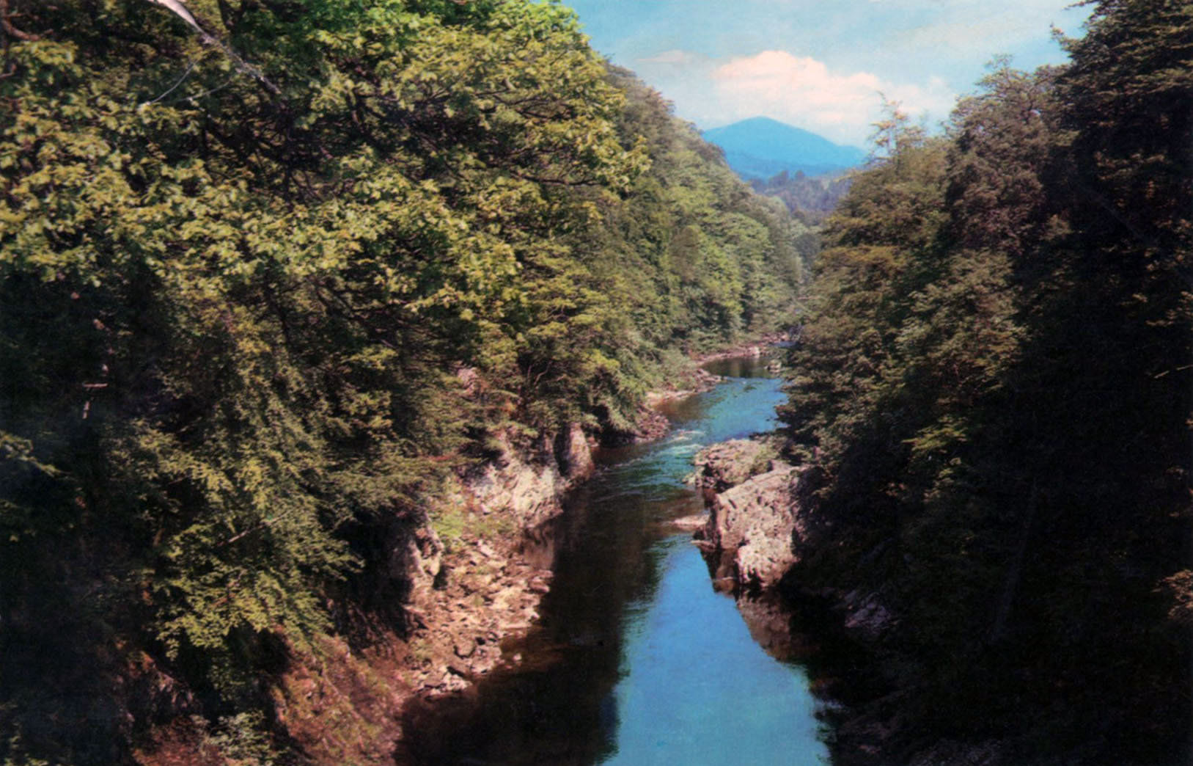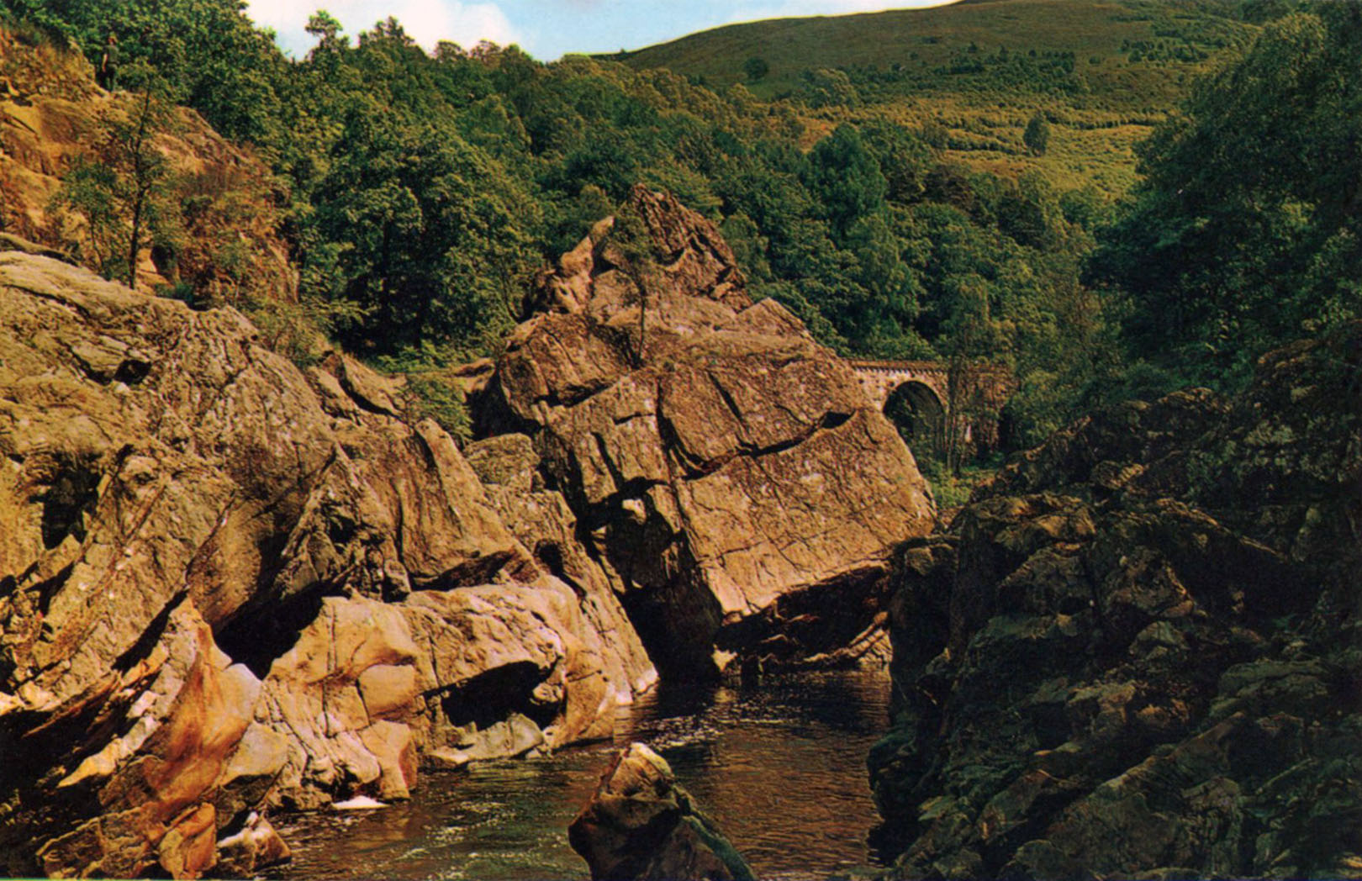
Pass of Killliecrankie Soldier’s Leap, Killiecrankie

Meanwhile, Glip¹⁶ and Ian¹² with the older Scouts²⁰ had departed for a climb of the famous Schiehallion (3547’).²¹ This hill is of particular historical interest to scientists as it was used in one of the early attempts to weigh the earth.²²

When the various groups return to base, dinner preparation ensued. Glip¹⁶ went off to check up on the ASS⁸ hikers. The weather by that time was glorious. First of all, Peter²³ arrived with S. Eadie in tow and later on Calum²⁴ and Dim²⁵ arrived. Generally, the place was quite busy – just like old times. Even the Bell was considerably more lively, Kenny’s air bed being strategically attacked by a special Grant²² device.

Scribe: Kenneth W. Paton ASL

Editorial comments
16. Graham Patrick
16b The SS hikers were Colin Roach, Donald Ross, Kenny Kerr and John Chalmers.
17. Tommy Boag, Peter McLean, Murray Brabender and Douglas Haldane
18. Isabel McBride
19. This on the B8019 on the north shore of Loch Tummel (Grid ref 863597)
20. Paul Edgar, Bruce Black and Stuart Patrick
21. Grid reference 714547, starting from the car park on the east side near Mon (Grid ref 753557)
22. The hill is roughly symmetrical and measurements were taken in 1774 as to how much a plumb line deviated from the vertical on both the north and south sides of the mountain at identical altitudes. The deviation would correspond to the density and volume of the mountain (which could be estimated) relative to the density and volume of the earth (which was to be ascertained). The density of the earth was determined as 4,500 kg m⁻³. In 1798, the experiment was repeated leading to a density of 5448 kg m⁻³. The currently accepted figure is 5525 kg m⁻³.
23. Peter Bennett
24. Calum Grant
25. Douglas Morrison

Saturday, 6 August

We awoke to a glorious sunny morning and the sound of Cubs’ voices (somewhere about 7 AM). We went back to sleep for another hour and a half.

After breakfast of slice rolls, the morning was spent on training and testing with particular attention to as many of the Scout Standard⁹ tests as possible.

The ASS⁸ hikers returned just after lunch and while Graham organized some fun camp activities, the Cubs²⁶ accompanied by Akela¹⁸, Peter²³ and Kenny¹³ headed into Pitlochry to visit the dam and salmon ladder (not to mention buying ice cream etc). This was very interesting. We also had a look at the Hydroelectric Board exhibition. The Cubs then joined the rest of the Scouts in Pitlochry for a fish and chip tea while the Leaders headed for the slightly more palatial surroundings of Fisher’s Hotel Restaurant.²⁷

In the evening, some of the Scouts went to the pictures (À la Walt Disney)²⁸. Some of the leaders went to the Pitlochry Festival Theatre (a historical play)²⁹. Back at the campsite, Ian¹² organized a deck teams tournament³⁰ and then took the Scouts for a climb up Dunfallandy Hill.³¹

All the various groups return to the campsite and headed off to bed somewhat fatigued after a very enjoyable day.

Scribe: Kenneth W. Paton ASL

Editorial comments
26. Kenneth Hyde, Glen Grant, Kenneth McCrae, Robert Wright, Gordon Brabender and Kevin Byng.
27. Situated on the south end of Pitlochry’s main street.
28. Not known which film this was. Possibilities include ‘The Shaggy DA’, ‘Freaky Friday’, and ‘Escape from the Dark’.
29. Title not known
30. This may refer to deck tennis or quoit tennis (see editorial comment 34).
31. This is within walking distance of the campsite, with the summit (1341’) at G.R. 943549. An OS map from 1966 shows that there were no trees on the northern slopes and that access was relatively straightforward from the campsite. Indeed, the hill was climbed by 70th Scouts during at least one previous camp. The OS map printed in the year 2000 shows that the hill is now covered in forestry with no obvious path to the top. It is presumed that forestation occurred after 1977.

Sunday 7th August

An early rise was called for as we were to attend the morning service at Moulin Parish Church³². After a breakfast of scrambled eggs, the ferrying to Moulin began. The service was conducted by a mission team from Dundee as the regular minister was away on holiday. We were subjected to a children’s address on the time honoured subject of ‘camelephantelopelicananel’³³ etc.

When we returned to camp, we discovered that some of the parents had already arrived and there was a steady stream throughout the afternoon. Most of the parents took their offspring out to lunch.

For those who were not out of camp, the afternoon was spent mainly either lazing about the campsite or playing deck tennis³⁴ – a constant source of amusement.

After dinner of roast chicken, Calum,²⁴ Dim²⁵ and Peter²³ departed for Greenock.

The evening was spent in camp craft activities and the day finished with an informal campfire at Eggy’s³⁵ patrol kitchen.

Scribe: Kenneth W. Paton ASL

P.S. A rather sleepless early part of the night was had by Akela¹⁸ and Kenny¹³ as some Scouts ( who shall remain nameless) participated in some rather annoying nocturnal activities. For example letting Akela’s tent down.

Editorial comments
32. Situated to the north of Pitlochry at G.R. 944592.
33. Significance of this not yet discovered.
34. Deck tennis (also called ring tennis) gets its name because it was played on ships and involved throwing a quoit or rubber ring over the net.
35. Paul Edgar

Monday 8th August

A somewhat later start to the day’s programme occurred because two of the Scouters³⁶ had a long lie (until about 10.15). After a hurried breakfast and inspection, the morning was spent on training and testing while the Cubs got ready to depart. The final of the junior deck tennis³⁴ was held, the winner being Andrew Wilson.

After lunch, the Cubs²⁶ left and the rest of the Scouts spent the entire afternoon on a service project to the owner of Easter Dunfallandy House³⁹, which involves spreading gravel over the road⁴⁰ up to the house. Let it be recorded that all the Scouts worked extremely hard on this project, especially in the very hot weather. During the afternoon we had a visit from Brian (Scott)⁴¹ and his fiancé Ann McArthur who we were pleased to welcome to her first 70th camp. We wish them well.

After dinner, which consisted of mince and potatoes, and was prepared by the APLs as the PLs were away on their night out, the younger Scouts amused themselves on a blindfold rope trail prepared by Glip¹⁶ and a block and tackle device⁴² prepared by Benny.⁴³ Skipper⁴⁴ and Moira⁴⁵ arrived to a great welcome just after dinner also.
Pit ensued.

Scribe: Kenneth W. Paton ASL

Useless Historical Note
The S.L.⁴⁶ wishes it recorded that while visiting the camp he slept on exactly the same spot as when he was a little Kingfisher at his first summer camp in 1957!

Editorial comments
38. Kenny Paton was one of the guilty pair (see Glip’s log). Akela may have been the other (presumably due to the late night mischief described above).
39. Located close to the campsite up a side road (GR 949560). The property is now advertised as a self-catering property accommodating 6 persons in 3 double bedrooms.
40. Specifically to fill in the pot holes.
41. Brian Scott was a deep-sea marine engineer. He held a warrant as an Assistant Scout Leader and helped out at the 70th when he was not at sea. He was one of the Scouters present at the Troop’s Summer Camp to Wray Castle in the Lake District.
42. This was a pulley system that was set up to pull a dixie of water up the slope from the River Tummel to the campsite.
43. Alastair Bennett
44. Alastair Cram
45. Moira Cram
46. Scout Leader Alastair Cram

Tuesday 9th August

After breakfast, the trip prepared to go for a climb up Ben-y-Vrackie⁴⁷ (2,757 ft). They were ferried out to Moulin³² and from there under Glip¹⁶ and Ian¹² headed for the summit. This seems to have been very much enjoyed.

During their absence, the camp was visited by the local DC⁴⁸ Mr. Ogg (no relation to Angus⁴⁹) who seemed to be favourably impressed with our campsite.

Most of the Scouts spent the rest of the afternoon in Pitlochry doing last minute shopping etc and paying their last visit to the Milk Bar.

After dinner (haggis, neeps⁵⁰ and potatoes), site clearance began and thus continued for most of the evening.

The last day at camp ended with a face feed and campfire, and everyone somewhat reluctantly headed to bed.

Scribe: Kenneth W. Paton ASL

Editorial comments
47. The map identifies the mountain as Ben Vrackie (841m) at Grid reference 951633.
48. District Commissioner
49. Angus Ogg was a comic strip that ran in the Daily Record and The Sunday Mail until 1989. It was set in the fictional island of ‘Drambeg’ in the ‘Utter Hebrides’.
50. Turnips

Wednesday 10th of August

A hectic day to say the least. After a fairly early rise, breakfast was followed by presentation of Scout Standards⁹ to John Chalmers and Donald Ross, and Camper’s badges to Slip⁵¹, Harry⁵² and Guy⁵³. Well done!

Thanks to a kindly farmer who loaned us his Land Rover. We were able to get the gear ferried down to the caravan site where that bus awaited us.

And so to home – very reluctantly.

Scribe: Kenneth W. Paton ASL

Note
Novice Camper Award – Kenneth Kerr
Campers Award – Douglas Haldane

Editorial comments
51. Stuart Patrick
52. Harry Lochead
53. Guy Grant

