SUMMER CAMP

1978

BLACKWOOD, LOGIE, FIFE

THOSE IN CAMP

The French Connection The Herbs
P.L. C. Adams (Lum) P.L. G. Grant (Patland)
A.P.L. A. Calder A.P.L. D. Haldane (Mongol Doogie)
G. White (Scary Gary) S. Thomson
G. Wilson C. Roach (Shrew)
P. Cotel (Kermit) R. Lawrie (Bod)
K. McCrae G. Brabender (Gordy Gordy)

The Pipe Cleaners The Stinkers
P.L. C. Terris (Shug) P.L. T. Tully
A.P.L. W. Grant (Dome) A.P.L. C. Brown (Crow)
G. Dagleish (Chive) D. McEwan
D. Whiteford (Whity) G. Hotchkiss (Hotchkers)
A. Davies C. Griffin

The Bogbrushes The Corncobbers
P.L. B. Black P.L. B. Peacock (Queeny)
R. Mochrie A.P.L. B. Forbes
D. Eadie (Deedie) J. Dyer
A. Wilson (Raljex) A. Ross (Slim)
G. Bolster (Rivet) K. Hyde (Jekyll)
K. Byng C. Jess (C.J.)

The Fetishers Seniors
P.L. M. Brabender (Pucker) P.L. S. Patrick
P.L. C. Hunter (Chunter) P.L. D. Griffin
A.P.L. K. Fraser Venture Scouts
P. Clark A. Bennett (weekend only)
A. Bowes (Bosé) D. Thornton (weekend only)
A. Cowe (weekend only

Scouters Awards
A.B.C. Skipper Winning Patrol - Pipecleaners
K. Paton Q.M. Food Runners up - Herbs
D. McIlroy Q.M. Equipment Camper of the Year – D. Haldane (2nd
Glip First Aid and Treasurer year running)
C. Grant (Saturday onwards) Novice of the Year – K. McCrae
M. Cram (Monday onwards)
D. Morrison (Sat-Sun)
P. Bennett (Sat-Sun)
G. Robertson (Sat-Sun)
Akela (Fri-Mon)

Monday 31st July 1978

The PLs, along with Philip Cotel, a French pen pal of Calum’s¹, left HQ in the minibus with Skipper² and David³. After an uneventful journey, we arrived at the campsite and set up the Patrol tents.

In the evening, the PLs explored St. Andrews, while the Scouters, having fed their face, shot off to see various Guider types about keys for their equipment store on the site.

Weather was good – far too hot to pitch tents!
Overnight, we were entertained to thunder – but only a little rain.

Author: Skipper

Editorial notes
1. Calum Adams
2. Alistair B. Cram (Skipper)
3. David McIlroy
3. Philip Cotel (a French pen pal of Calum Adams)

VISITORS PAGE

Katherine Allen 2nd A Leven Brownies Assistant Brownie Guider
Pat Mathieson 1st A Methil Brownies Brownie Guider
Bernard W. Pirie Cupar District District Commissioner
Betty Rodgers Ex-Akela (70th)
Craig Rodger Ex-32nd Renfrewshire
**** 77th West Herts ex Chaplain
**** (wife) 77th West Herts
Margaret S. *** Kirkcaldy District VI Camp Advisor
Donald Sinclair Logie Minister Emeritus
Douglas Waddell 13 Victoria Place, Stirling

Tuesday 1st August 1978

The troop met at H.Q. at about 08.30. The bus which was to take us to Blackwoods arrived late, so that we had to carry the equipment to the parade ground and wait.
Eventually, the bus came and we left after trying to store the equipment neatly.
The bus journey was fairly uneventful except that a camp idiot was discovered. ¹
When we got to camp about 12.30, there was a mad rush to get each Patrol’s own equipment to the Patrol’s kitchen shelters. When this was done and everyone had changed, many of the younger Scouts vanished unsure what to do? However, by teatime, there was a semblance of order beginning to appear in the kitchen shelter. This was inevident in one or two kitchen shelters. Organisation included an office, a first aid tent.
In the evening, games were organized – badminton, rally-cross cycling² and archery. After one and all had supper all retired to bed.

Robbie Mochrie
Bogbrush Patrol

Editorial notes
1. The significance of this has yet to be determined
2. This may well be the first year that cycles were taken to camp to be used within the camp itself either recreationally or for patrol quartermasters to get to the store tent more quickly. They proved a huge success and were a feature in several future camps. The downside was the difficulty in transporting them to and from camp. Cycles were taken to summer camps at West Loch Tarbert during the 1960s and were used to cycle to and from Tarbert, but there are no reports of them being used in the camp itself

Wednesday 2nd August 1978

At 8:45, most of the Scouts were up and making breakfast, which was bacon and tomatoes.
After that, the inspection was the next thing for the patrols to worry about especially the Stinker patrol which wasn’t very organized then.
At about 10.00, the games were going well, football and rugby!
Very soon it was time for lunch just after the tuckshop opened.
After the midday meal was over, most of the Scouts went in the minibus to St Andrews which was only about 7-8 miles away. After mucking about there in he drizzly rain, we came back just in time for tea. After that, there was training and testing and there was meant to be a campfire, but it was postponed because of the rain, so the Scouts just went to their pits after a hot drink and a biscuit.

Douglas MacEwan
1st Scout Stinker Patrol

P.S. It was Shrew’s birthday today, so he got a birthday cake from the Scouters and some rum flavoured chocolates from his patrol. Apparently, unknown to the Herbs, the chocolates actually had a rum-filled centre which was reported to have produced a startling transformation in Shrew’s face from initial surprise to and unadulterated glee. GLP
P.P.S At nightfall, there was an invasion of Brownies who were intending to join in the cancelled campfire! GLP¹

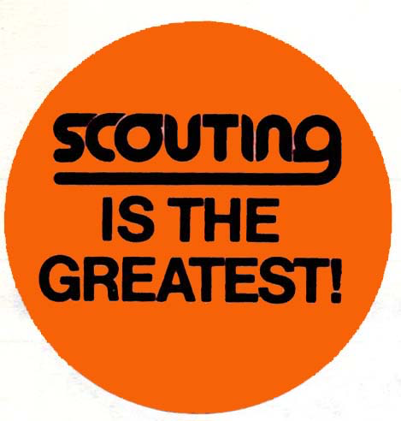

Stickers which were plastered over all the visiting Brownies. Propaganda war!

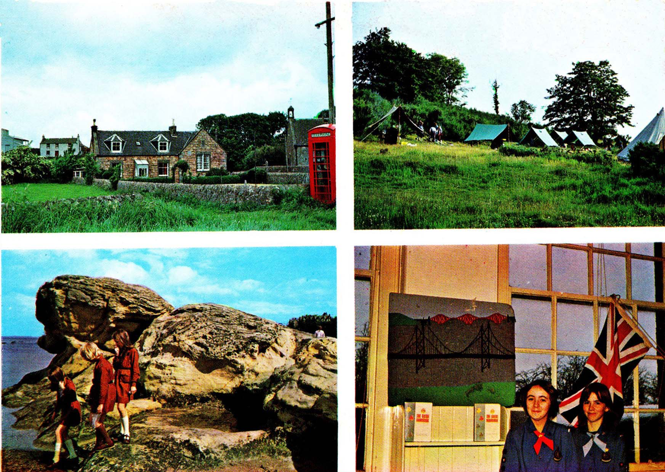
The Official Camp Postcards 5p each

Editorial notes
1. It is not known which PLs actually issued the invitation and why Brownies were invited rather than Guides. It’s also not known whether any of the other Scouters were aware of this before the Brownies arrived.

Thursday 3rd August 1978 – No report

Editorial notes
It is not known why this particular day was left unreported. According to Glip’s log, there was football in the morning. In the afternoon there was pyrography and plaster casts for the younger Scouts while the older Scouts put up a climbing net. Glip set up a 9-hole camp golf course. It is thought that this was the first time that a camp golf course was set up. Empty food tins were used to line the holes and the turf removed was stored such that it could be replaced at the end of camp. Care had to be taken to avoid using tins with sharp edges. Old golf clubs were donated to the troop by Glip for use by the Scouts. Plastic golf balls were used rather than real ones for reasons of safety. A bit of research had to go in to finding balls that would fly a reasonable distance. Golf balls with no holes flew further than those with holes, but the latter were fine if duck tape was used to cover the holes.
In the evening, badgework and T & T took place, while Skipper returned to Greenock in the minibus so that he could return with Akela and the Cubs the next morning. Unfortunately, a couple of PLs took it into their heads to leave camp and did not return until 2am. Fortunately, this was a one-off incident in terms of 70th summer camps.
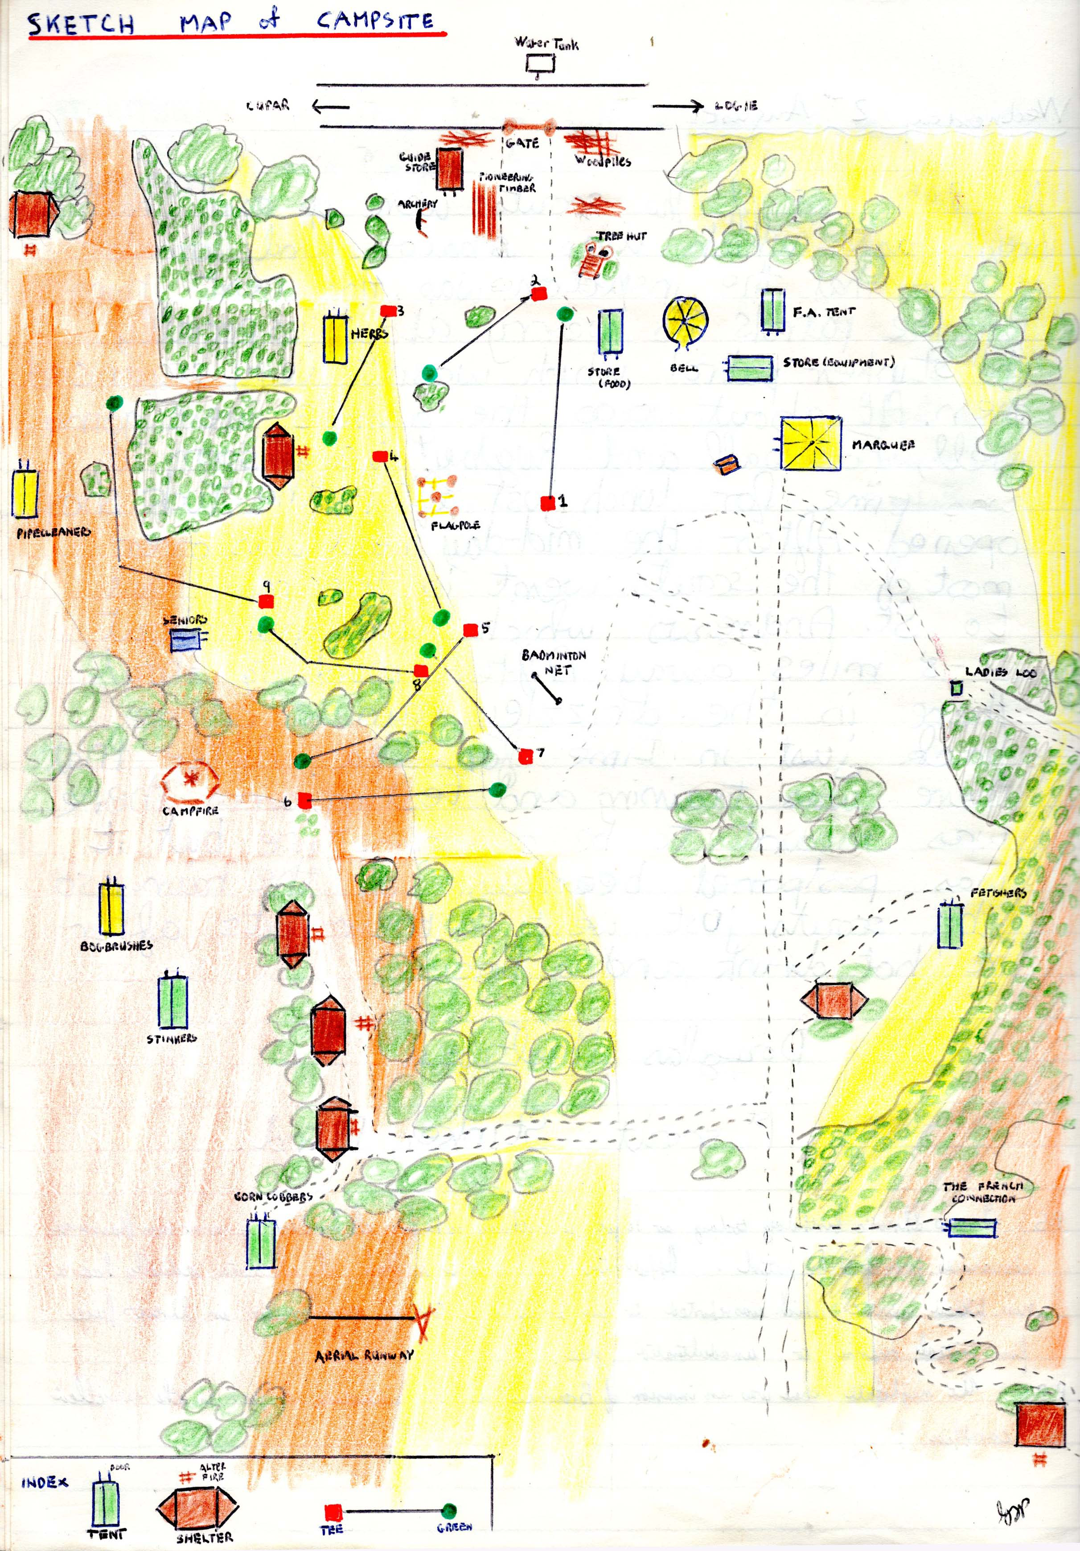

Friday 4th August 1978

The patrols were late in rising and there was very little achieved in the morning.
During lunch of soup, pies and fruit, Skipper¹ arrived with Akela² and the Cubs³ in the minibus. After the Cubs had wolfed down their lunch, the pitched their tents with the help of Patland⁴ and D Haldane, then spent the rest of the afternoon playing golf, archery and badminton. A dozen Scouts went with Kenny⁵ to go pony trekking, but never got there⁶ in fact because the minibus got lost. The rest of the Scouts sunbathed or played games for the rest of the afternoon.
Dinner consisted of mince, tatties and carrots, and a dessert made by Kenny.
After dinner, the grand camp sports were held organized by Glip and David⁷. The first event was ring wrestling. This was very exciting and the great surprise of the event was the departure of CJ⁸ from the ring help on his way by Chunter⁹. The latter’s success did not last long as he was flung out with aplomb by Lum¹⁰ in a later contest.
The second event was welly hurling which was won handsomely by Lum.
The third event was tug-o’-war which was won easily by the French Connection, although there were complaints by them when they lost the second pull when their opponents appeared to double in strength at the same time as the spectators disappeared.
The fourth event was a 50 meter hopping race fought closely between Lum and Doogie. ¹¹
The fifth event was a piggy back race up the hill which was won by Doogie and partner with Lum and partner close behind.

Glip

Editorial notes
1. Alistair Cram
2. Isabel McBride
3. David McEwing, Roderick McCrorie, Colin Speirs, Callum Gillespie, Euan Blair + ?
4. Guy Grant
5. Kenny Paton
6. It is not known where the pony trekking took place
7. David McIlroy
8. Colin Jess
9. Colin Hunter
10. Calum Adams
11. Douglas Haldane

Saturday 5th August 1978 Duty Patrol – Pipecleaners

Today, the quartermasters were given a few extra precious minutes of sleep. Two whistles rang round the camp at 8.45 AM. Callum Grant and Douglas Morrison had just arrived as I made my way to Kenny’s¹ store tent. The morning’s breakfast was cornflakes, milk, sugar, fried bacon and eggs and bread. Alistair Bennett and Donald Thornton arrived last night with Gordon Robertson.

At 10.30 a.m., three whistles peeled through the camp and the Scouts assembled for flag (break). After that, Bruce Black was presented with his Camper’s badge and Douglas Haldane received his Camp Cook’s badge. There then followed a game of football and hockey run by A. Bennett and D. Thornton.
At about 11 AM, I began to write the log. Skipper blew his whistle and addressed the mob. Test(ing) and training was the order of the morning. Glip ran First Aid and other tests, Douglas ran rescue notes, and Peter Bennett and Skipper went to Cupar to see the minister. Kenny and Akela made the lunch which was salad, lettuce, potato salad, pickled onions, beetroot, spiced roll and luncheon meat; crisps and oranges.

Skipper blew his whistle at 1.00 PM. Lunch was finished and cleared up. Everybody is now ready to go to St Andrews for the afternoon and tea. Will be back at 8 PM.
Left at 3 PM. Have fish and chips.
Kenny picked up the first lot going home at 9 PM. They arrived back at Blackwood at 9:30pm. After Kenny had ticked off their names, they were told to change and at three whistles come for supper.
The weather was still sunny but a cold wind was setting in. Some Scouts played cricket or badminton.
Akela and Peter Bennett arrived back.
Some PLs and APLs went to a discotheque in St Andrews. They will not be back till 11:30 PM. Philippe Cotel is with them also.
In St Andrews, there was a fair in Market Street, in which a market open normally resides, but once a year in August, the fair comes and the street is closed to traffic for four days. A lot of Scouts enjoy the fair because of the amusements.
On the way back to camp, the Scouts sang “Drown ? in the Rain” ² and “There’s a Rabbit”. Of course, a certain R. I. Mochrie declined from such tomfoolery.
Kenny/Akela put the kettle on because she hoped to have a cup of coffee.
I am writing in total blackness because Kenny cannot get the gas lamp started because it is empty. Kenny put the lamp on the trestle table outside to start the lamp but is not doing very well. At 10.00 PM, he lit the light but it is leaking. Kenny jumped back with fright and Akela told Deadie³, Douglas McEwan and Slim⁴ (?urch) ⁵ to stand back. They could evidently smell the gas leaking out of the lamp. I was then aided by Robert Wright who turned his torch on the log. Peter Bennett came over and complained of the smell. Kenny told Slim to go away. Kenny said it was quite simple but he is not doing very well. Peter Bennett tried to fiddle with the lamp but with no avail. Another attempt was unsuccessful but Peter Bennett had come to the decision, gas is escaping. The canister is removed and the new one is put on.
The minibus arrived back with part two of Scouts at 10:10 PM. Philippe Cotel did not go to the disco as first said. When Skipper arrived, everything was put right and light shines of vaguely through the marquee.
Supper is hot chocolate, fruit shortcake, Royal Scott and Ginger Nuts. Same as last night. The Cubs were horded into the marquee. They are having orange. For hours, the Scouts queued.
The Scouts went to kip after supper.

Signed Gordon Dagleish (Pipecleaners)

Editorial notes
1. Kenny Paton
2. The song was actually ‘Brown Girl in the Ring’, but presumably the words were modified and targeted at specific Scouts
3. David Eadie
4. Alistair Ross
5. Indistinct

Sunday 6th August Duty Patrol: Herbs

Most of us were awakened by either the accustomed whistle of Kenny¹ or the more agrophobic actuas² which were threatened upon us by Calum³. For breakfast, we had boiled eggs and rolls. Then either cornflakes, rice krispies or Whealatsix.⁴
The clearing up was then done and the uniforms were put on. Today’s inspection was uniformed and full of enthusiasm. We were then summoned to the flagpole in uniform or in CJs⁵ and Tommy’s⁶ case half uniform. We were then chauffeured to Cupar.
We were then assembled and then marched about 25 m (meters) to the Church. The sermon was based on Scouting and other such things. Afterwards, the PLs and APL’s were whisked away to the camp to get lunch ready.
For lunch, the Herbs had spaghetti, hot dogs and then, before all that, soup.
The afternoon’s activities were based under cover because of the unwanted weather.
1. Dumpling making
2. Pyrography
3. Bread making
4. Doing nothing (in the PLs and APLs case)

Some of us, who were doing the Explorers badge e.g. Myself, CJ, Patland, ⁷ Tommy, Dome⁸ and Crow⁹, went to Tentsmuir Forest and did some exploring.
The explorers arrived back with the aid of Bruce¹⁰, Mus¹¹ and the van at 6:30 PM to be greeted by a completely changed kitchen shelter. Skipper and squad had moved in, cooking chicken, pea soup and trifle which was excellent, especially the trifle. Well done, Kenny. I’ll recommend you to dirty Joe’s Caf.
We were then again summoned by Skipper to the flagpole. This time to summon help to clear up our kitchen shelter. Only two offered to help (Dede¹² and Dugey (McEwan)). This is when the D.C. arrived. He had already been yesterday but was greeted by an empty campsite.
After the shelters were cleared, I think, Glip then summoned us to the start of the Logie golf club open championship. The best score so far is 40 over par which was achieved by the recently unknown game keeper.¹³
Then came the troop log which I’m doing now. I will now have to wait until later on to finish it,
Here I’m again, some bad news to all you sportsmen. David Griffin and Pucker¹⁴ have given up in their attempt at the open. That just shows (what) being away from proper Scouting does to you. And some late scores from the open. Bod¹⁵ got a 79 for 9 holes. Andrew Davies got 63 for nine holes. Shrew¹⁶ got 94 for nine holes. Raljex¹⁷ got 74 for also nine holes. And another newsflash from the open. Kenny Hyde gets a 44 for the nine holes and 100 in total for the 18 hole course. We are still trying to believe Bowsies¹⁸ which beats the record by 28.
We were then sent to the kitchens we are devoured the home cooking and coffee then we went off to our kip. Good night,

Douglas Haldane A.P.L. Herbs

Editorial notes
1. Kenny Paton
2. Meaning unclear
3. Calum Grant
4. Presumably weetabix
5. Colin Jess
6. Tommy Tully
7. Guy Grant
8. Willie Grant
9. Crawford Brown
10. Bruce Black
11. David McIlroy.
12. David Eadie
13. Presumably meant to say greenkeeper (Glip)
14. Murray Brabender
15. Robert Lawrie
16. Colin Roach
17. Andrew Wilson
18. Alan Bowes

Monday 7th August 1978

It was dry (although Kenny¹ claimed it rained at some time) as sleepy Kenny arose to issue his stores. Breakfast consisted of French toast followed closely by a serving of training and testing where a power of work was completed.
Our lunch consisted of soup and fish fingers – enough said.
There was a frantic rush to clear up after lunch since we were going to Glenrothes for the afternoon. The bus taking us arrived at 2 p.m. before we were quite ready and it wasn’t till about 2.20 till we left with all the Scouts, Callum, ² David³ and Glip. The bus arrived at Glenrothes sports centre at 2:55 just in time since we had booked half a hall from three till five. The people at the hall were extremely helpful and the Scouts enjoyed themselves enormously. We were only charged £4.50 for half the hall and several Scouts took the opportunity to play badminton and football. Everyone had a swim for only 10p extra and we also had the great honour of having a welcome directed to us on the main noticeboard of the entrance hall.
As far as each activity was concerned, the following highlights occurred.
Swimming
Callum Adams practiced his swimming flowing at a high rate of knots from side to side of the pool⁴ while the rest of the PLs sat at the poolside admiring the female pool attendants. Rivet (Graham Bolster) swam around annoying Scouters by clinging round their necks and dragging them down to the depths. There was also the startling sight of a man whose torso was completely tattooed.
Badminton
A lot of people had a go and Shrew (Colin Roach) caught the eye with his flowing strokes and style.
Football
Nothing serious really.

We left dead on five for the campsite where preparations for dinner began. Dinner consisted of mainly haggis, tatties and neeps. In fact, half of the turnips were used as football! Fortunately, the Q.M. ⁵ was unaware of this.
During the day, of course, the Cubs⁶ left (as well as) Isabel⁷, Dim⁸ etc, and so the campsite was a little bit quieter.
After dinner, there was badge work. D. McI.³ set a trail for the observers to follow. Skipper briefed the Explorers for their hike, Glip took sweet making, Kenny did Camp Cooks. The marqueeee, in fact, was incredibly hectic with what seemed to be most of the camp trying to cram into its 6 yards x 6 yards.

Eventually we finished and hit the pit.

GLP

Editorial notes
1. Kenny Paton
2. Calum Grant
3. David McIlroy
4. Calum Adams was a keen swimmer and won the District Scout Swimming Competition the previous April
5. Quartermaster Food was Kenny Paton
6. David McEwing, Roderick McCrorie, Colin Speirs, Callum Gillespie, Euan Blair + ?
7. Isabel McBride
8. Douglas Morrison

Tuesday 8th August 1978

It was dry, fortunately, since the hikers were starting off today. After flagbreak and inspection, the explorers and ASS hikers left in the minibus while the rest of the campsite got down to game, training and testing. Just before lunch, the SS¹ hikers departed (A. Bowes, G. Hotchkiss and K. Hyde).²
Lunch was a quick beefburgers and spaghetti.
After lunch, the pony trekkers departed leaving a very quiet campsite. However, the afternoon was put to good use since Skipper, Bruce³, Crawford⁴, Brian⁵ and co constructed an aerial runway⁶.
The hikers meantime were trekking the countryside. Their aim was to visit four places of interest, a monument, abbey etc and to follow a route avoiding A class roads. There were, in fact, three groups consisting of
B. Forbes, C. Adams, A. Wilson and D. Haldane
W. Grant, T. Tully, C. Brown
C. Jess, B. Peacock and A. Calder

Back at the campsite, dinner consisted of beef olives followed by a splendid pear condé made by Kenny⁷ which was quickly devoured.

Evening activities included sweet meeting with Glip at Shug’s (Colin Terris) kitchen where fudge, toffee and chocolate krispies were made, pennant printing with Kenny in the marqueeeeee, and Camper’s badge with Skipper.

GLP

Editorial notes
1. Scout Standard
2. The route is shown on a sketch map found in Glip’s log
3. Bruce Black
4. Crawford Brown
5. Brian Peacock
6. From memory, it had been some time since an aerial runway had been set up camp due to tightening up of the regulations. In the 1960s, Scouts used to go down the runway hanging onto a bit of wood. The new regulations required a proper seat to be used. This was prepared in advance of the camp and a brand new rope was purchased from the Glasgow Scout shop. The rope was massive and this was another item that took up a lot of space during transport to and from camp.
7. Kenny Paton

Wednesday 9th of August 1978

After breakfast and an informal inspection, there was a game of non-stop cricket with Scouter participation. Callum Grant’s side were lucky winners in the end.¹ During the game, PLs and APLs worked on a tree hut.

There was no time for T&T² before lunch which was backwoods (chops and apples etc).

After lunch, a dozen pony trekkers left, leaving the rest to spend a lazy afternoon in camp, except, that is, for C. Hunter and G. White who worked hard on their mapmakers badge.

Midway through the afternoon, the Explorers returned from their hike and several continued work on the tree hut. Another dozen went pony trekking and we got a visit from the minister who was quite impressed, even with the mess. In fact, the sun actually came out for a couple of hours which caused problems for the badminton players.³

For dinner, there was soup followed by a vegetable stew which wasn’t all that good by most accounts.

After dinner, there was more work on the tree hut and after dark, there was a wide game. The story involved an invasion by the Outer Siberians versus the Mongolians. The object was for the invaders to gain access to the equipment store tent any way they could. Apart from that – no rules.

A second wide game was also held where five lunatics (C. Grant, David McIlroy, Slip,⁴ S. Thomson, G. Hotchkiss) had escaped from the asylum and were hiding in the campsite. The rest of the players (wardens) had to find them. The first lunatic spotted was D. McIlroy and there followed an exciting chase accompanied by yells of “Luné!” and “Hauners!” which stretched over half the campsite before D. McI was caught. Sandy and Hotchkers⁵ were caught next, but Calum⁶ and Slip evaded the chasers and reached the safety of the marquee.

There was a quick communal supper, then pit.

GLP

Editorial notes
1. That was because they beat Glip’s team
2. Training and testing
3. The problems were due to the sun making it difficult to see the shuttlecock.
4. Stuart Patrick.
5. Graeme Hotchkiss
6. Calum Grant

Thursday 10th of August 1978

The day dawned to a portion of French toast¹ for breakfast. It was cloudy but dry and as the day wore on we got the occasional sunny period.
After flagbreak* and inspection, there was no game for a change and a concentrated session of T & T was carried out. *NB GREAT EVENT! A new S.P.L. ² was appointed, the admirable Shug or Colin Terris for short. Crawford Brown and Gabby³ gained their Camp Cooks badge (and) it was announced that Slip⁴ and B. Black had gained their CSA bar the interview.
After all those promotions and badge presentations, T & T⁵ proceeded. Slip did knife and axe, Calum⁶ taught CSA car mechanics, David⁷ worked with Observers, Skipper taught risky knots, a PLC⁸ was held for K. Hyde’s Scout Standard, C. Hunter and G. Whyte did a 2 mile road walk for part of the map makers badge, and D Haldane and G. Grant finished off their Explorer badge by completing a 3-mile compass hike near Tentsmuir forest.
After all this frantic activity, lunch was prepared consisting of chicken noodle soup, corned beef hash and afters. The cleanup was completed just in time before the bus arrived to take everybody, bar Callum⁶, David⁷ and Glip, into St Andrews for a final shopping spree.
Once everybody had returned, dinner was prepared of soup, spaghetti bolognaise and fruit. During this, Sandy Thomson managed to pour his spaghetti over his foot, which was rather sore at the time.
After dinner came the grand clear up where most of the kitchens were dismantled and taken to the minibus. After a couple of hours hard work, the final campfire was staged and this turned out to be very successful. A hot drink was had and everyone was in pit by midnight.

N.B. Several Observer badges were awarded to D. McEwan, C. Griffin, A. Wilson, G Bolster, K. Hyde, K. McCrae.
Camp Cooks were awarded to C. Brown and M. Brabender, D. Haldane.
Campers badge was awarded to G. White, B. Black

GLP

Editorial notes
1. Bread dipped in whisked egg, then fried
2. Senior Patrol Leader
3. To be identified.
4. Stuart Patrick.
5. Training and Testing
6 Calum Grant
7. David McIntyre
8. Patrol Leaders’ Council. The patrol leaders were responsible for training and assessing Scouts for the Scout Standard. The PLC interviewed the Scout once he had completed all the tests to make sure that he still ‘knew his stuff’. Scouters were not present at this meeting.

Friday 11th August 1978

When we woke up, it was cloudy but dry. However, as the morning wore on, the sun started to force its way out and by midday it was beautiful and sunny, easily the best day of camp. This was hardly surprising, I suppose, since we would spend most of the day in the bus going home.¹
Once the patrols were up, the final clear up began in earnest with a short break for communal breakfast of cereal and boiled eggs. The patrol tents were struck last followed by the Bell and the marquee. A.B.C. ² left about 1 PM in the mini bus. Our bus arrived early at 1:45 in the middle of lunch (soup and crisps),which caused a slight panic.
The very last job was flagbreak and the bringing down of the flagpole. This latter task brought the second panic of the day when the pole decided to fall the wrong way and tried its best to clobber Crawford Brown. After a final inspection which was quite good we were ready to go.
The final awards were announced before departure. The patrol competition was won by the Pipecleaners with the Herbs a very close second. Camper of the Year for the second year running was D. Haldane and the Novice of the Year was K. McCrae who was presented with a sheath knife. Murray Brabender received his A.S.S.³ and four Scouts received their S.S.⁴, K. Hyde, G. Brabender, A, Davies, D. Whiteford.
Two scouts, G. Grant and D. Haldane, received the Explorers badge⁵ – the first in the troop to get this particular badge.
The bus journey home was uneventful and we unloaded the bus in record time.

GLP

Editorial notes
1. It was always a bit irritating to leave camp on a nice sunny day.
2. Alistair Cram
3. Advanced Scout Standard
4. Scout Standard
5. The Explorer proficiency badge was distinct from the Explorer Badge that was introduced when the Scout Standard and Advanced Scout Standard were replaced with the Pathfinder and Explorer Badges in 1984.

